**Proposal - Project 2**

Project Topic:

The chosen topic will be the COVID-19 pandemic virus and a review of what medications are administered to patients who are infected with the virus. The rationale to select the topic of COVID-19 is the relevancy of the current pandemic. The virus continues to spread at an alarming rate throughout the United States and the world. The data we hope to uncover will show what medications are medical professionals using to treat infected COVID-19 patients and the effectiveness of the different medications currently in use.

Project Language:

SQL

Plotting Examples:

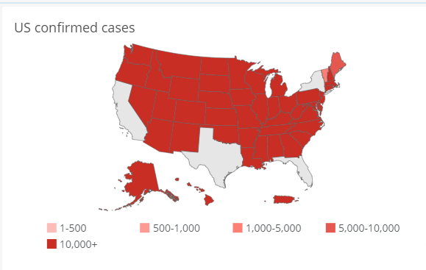 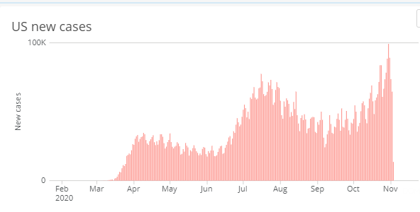

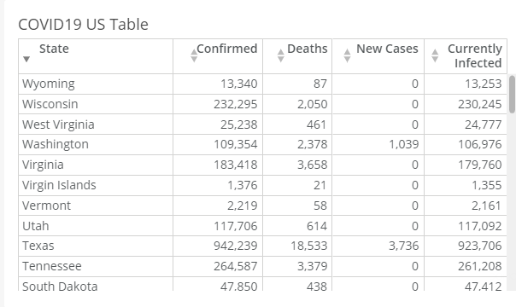

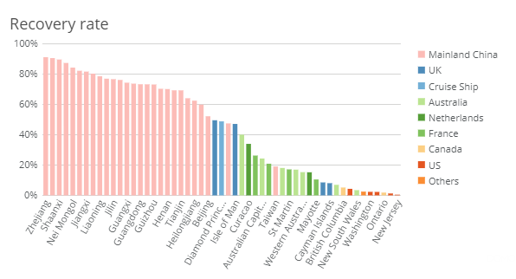

GitHub Repository Location:

<https://github.com/lazambrano/Project_2_COVID-19>

Team members: Eltahir Gotar, Anthony Avitia, Leo Zambrano.